Thursday 4 Februay 2021

Junior Syndicate trip to Wellington Botanical Gardens

Tuesday 23rd February

We will be visiting the Discovery Garden in Wellington Botanical Gardens.
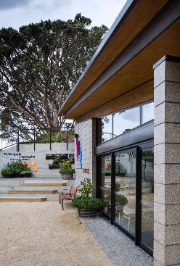
Students will be learning about Rongoā/Maori traditional medicine and the use of cultivated plants for healing. In this programme we take a walk to identify the native trees and discuss their uses, make observational drawings about the plants in the ‘Lotions and Potions’ garden and make an itchy bite balm.
Everyone will also be visiting the Children’s Playground.
Children need to come in their P.E. gear. They need to bring, packed into their school bag;
Packed lunch and drink bottle School jersey
School sunhat Raincoat
Please ensure you provide your child’s teacher with any necessary medications (e.g. inhalers).
We will require lots of parent help on the trip. Please indicate your availability and return the slip below by Tuesday 16th February.

Junior Syndicate Botanical Gardens visit (form returned by 16/2/21 please)
Child(ren)’s name ___________________________ Class(es) _____________________
have my permission to travel by bus for an educational visit to Wellington Botanical Gardens on Tuesday 23rd February.
I would love to help / Sorry, I am not available (please select one)
Signed ______________________ Your name____________________________
Contact number ____________________________________________________

